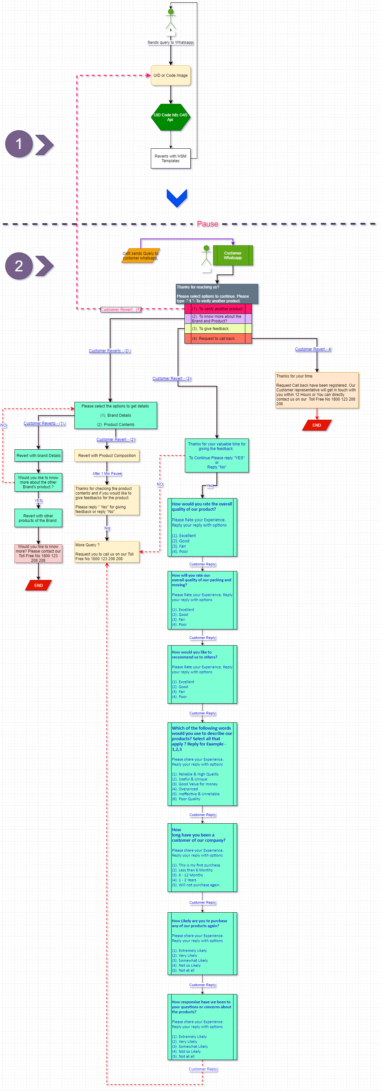

Please enter a UID Number or Scan a QR to verify your product.